**Revision Sheet**

|  |  |  |
| --- | --- | --- |
| **Release No.** | **Date** | **Revision Description** |
| Rev. 0.0 | 11/02/2017 | Application guideline template |
| Rev. 0.1 | 11/29/2017 | Frist version |
| Rev. 0.2 | 12/13/2017 | Added data logging and protection coordination |
| Rev. 0.3 | 12/14/2017 | Added communication |
| Rev. 0.4 | 12/15/2017 | Integrate all parts together, first complete version |
| Rev. 0.5 | 01/22/2018 | Updates figures |
| Rev. 0.6 | 10/17/2018 | Updates new function blocks and Instruction for utilizing the microgrid controllers with a new feeder |
| Rev. 0.7 | 04/01/2019 | Modification on the main body |
| Rev. 0.8 | 06/28/2019 | Add the Planned/unplanned islanding, topology identification, fault and abnormal state control;  Revise the new MG implementation |
| Rev. 0.9 | 06/28/2019 | Modified for basic version on GitHub |

----------------------------------------------------------------------------------------------------

Copyright <2019> <The University of Tennessee at Knoxville and the University of Tennessee Research Foundation>a

This software is released under BSD-3

https://opensource.org/licenses/BSD-3-Clause

Additional license options available at https://utrf.tennessee.edu/industry/sample-agreements/

----------------------------------------------------------------------------------------------------

**TABLE OF CONTENTS**

Page #

1. INTRODUCTION 2-1

1.1 Purpose 2-1

1.2 Organization of the guideline 2-1

1.3 References 2-2

1.4 Authorized Use Permission 2-2

1.5 Acronyms and Abbreviations 2-2

2. System function block summary 2-1

2.1 System Configuration 2-1

2.2 User Access Levels 2-3

3. GETTING STARTED 3-1

3.1 Download, Installation and Requirement 3-1

4. MICROGRID CENTRAL CONTROLLER 4-4

4.1 Finite State Machine 4-5

4.1.1 Functionality description 4-5

4.1.2 Function Block diagram 4-5

4.1.3 Algorithm flow chart 4-9

4.1.4 Function inputs and outputs 4-9

4.2 Model Management 4-10

4.2.1 Functionality description 4-10

4.2.2 Function Block diagram 4-10

4.2.3 Function inputs and outputs 4-10

4.3 State Estimation 4-11

4.3.1 Functionality description 4-11

4.3.2 Function Block diagram 4-11

4.3.3 Algorithm flow chart 4-11

4.3.4 Function inputs and outputs 4-12

4.4 Data logging and event recording 4-12

4.4.1 Functionality description 4-12

4.4.2 Function Block diagram 4-13

4.4.3 Function inputs and outputs 4-13

4.5 PV Forecast 4-13

4.5.1 Functionality description 4-13

4.5.2 Function block diagram 4-13

4.5.3 Algorithm flow chart 4-14

4.5.4 Function inputs and outputs 4-14

4.6 Load Forecast 4-14

4.6.1 Functionality description 4-14

4.6.2 Function block diagram 4-15

4.6.3 Algorithm flow chart 4-15

4.6.4 Function inputs and outputs 4-16

4.7 Energy Management 4-16

4.7.1 Functionality description 4-16

4.7.2 Function block diagram 4-16

4.7.3 Algorithm flow chart 4-17

4.7.4 Function inputs and outputs 4-17

4.8 Communication 4-17

4.8.1 Functionality description 4-17

4.8.2 Function block diagram 4-18

4.8.3 Algorithm flow chart 4-19

4.8.4 Function inputs and outputs 4-20

4.9 Black Start 4-21

4.9.1 Functionality description 4-21

4.9.2 Function Block diagram 4-21

4.9.3 Algorithm flow chart 4-22

4.9.4 Function inputs and outputs 4-22

4.10 Planned/Unplanned Islanding 4-23

4.10.1 Functionality description 4-23

4.10.2 Function block diagram 4-23

4.10.3 Algorithm flow chart 4-24

4.10.4 Function inputs and outputs 4-25

4.11 Fault and abnormal state control 4-26

4.12 Resynchronization 4-27

4.13 Topology Identification 4-28

4.14 Islanded state control 4-29

5. MICROGRID LOCAL CONTROLLER 4-32

5.1 Active power control 4-32

5.1.1 Functionality description 4-32

5.1.2 Function Block diagram 4-32

5.1.3 Algorithm flow chart 4-33

5.1.4 Function inputs and outputs 4-33

5.2 Reactive power control 4-34

5.2.1 Functionality description 4-34

5.2.2 Function Block diagram 4-34

5.2.3 Algorithm flow chart 4-34

5.2.4 Function inputs and outputs 4-35

5.3 Resynchronization 4-35

5.3.1 Functionality description 4-35

5.3.2 Function Block diagram 4-35

5.3.3 Algorithm flow chart 4-36

5.3.4 Function inputs and outputs 4-36

6. INSTRUCTION FOR UTILIZING THE MICROGRID CONTROLLER WITH A NEW FEEDER 4-39

6.1 Microgrid topology acquiring 4-39

6.2 Create the inputs for the model management 4-45

6.3 Create the communication channels 4-47

6.4 Initialize the microgrid controllers 4-50

6.5 Microgrid controller operations 4-51

7. Report and feedback 7-1

7.1 Report an error 7-1

7.2 Feedback 7-1

**1.0 INTRODUCTION**

# INTRODUCTION

This chapter presents an overview of microgrid (MG) central controller (MGCC) and local controller (LC) features as well as a brief description. The outlines of this documentation and a list of references and abbreviations are also provided.

## 1.1 Purpose

The purpose of this document is to define the functionality that will be developed by the University of Tennessee for ARPA-E project. This document serves as the sole reference for the scope of the system functionality and operation guideline. Any change to the scope of the project or the functional specifications will be updated in an open source approach.

## 1.2 Organization of the guideline

The application guideline consists of five sections: Introduction, System function block summary, getting started with the controller, report and feedback, and appendix.

Introduction section explains in general terms the controller and the purpose for this guideline.

System function block summary provides a general overview of the MGCC controller. The summary outlines the uses of the controller software requirements, controller configuration, and brief function introduction of each function block.

Getting started with the controller explains the every detailed description of each function blocks including the block diagram and algorithm flow chart as well as the procedure to apply this controller to a new feeder.

Open source report and feedback section describes how to join the open source software development, where to download the latest version, and how to feedback any information to us.

## 1.3 References

References that were used in preparation of this document in order of importance to the end user.

<http://curent.utk.edu/>

<https://bitbucket.org/microgrid/profile/repositories>

Github link

## 1.4 Authorized Use Permission

This controller is open source for the basic version. Thus every developer is welcomed to join and download the software through bitbucket. However, the advanced developed functions such as PQ balance, planned Islanding, state estimation, load/PV forecasting, energy management, and etc, are not available for the Beta version.

The application of this MG controller is limited to the education and non-commercial use. The commercial use should have the permission from ARPA-E, UTK, and EPB.

## 1.5 Acronyms and Abbreviations

Provide a list of the acronyms and abbreviations used in this document and the meaning of each.

|  |  |
| --- | --- |
| NI | National Instrument |
| MG | Microgrid |
| MGCC | Microgrid Central Controller |
| FSM | Finite State machine |
| PV | Photovoltaic |
| ARPA-E | Advanced Research Projects Agency–Energy |
| UTK | The University of Tennessee |
| EPB | Electric Power Board of Chattanooga |
| DAQ | Data acquisition |
| DNP | Distributed Network Protocol |
| IntelliRupter | A smart switch |

**2.0 SYSTEM FUNCTION BLOCK SUMMARY**

# System function block summary

System function block summary section provides a general overview of the controller software. The summary outlines the uses of the system’s hardware and software requirements and system configuration.

## 2.1 System Configuration

The overall software configuration is shown in the *Figure 1*. There are overall eleven different function blocks in MGCC. Each function block can work and be tested individually. Due to the benefits of the LabVIEW programming, these function blocks are working in parallel. Therefore, the enable and disenable function would be simple. In the following paragraph, a simple summary for each function block would be given.

Finite State Machine: The core of the MGCC which is the state control function block of the MGCC. It collects all the feedback information from each function block and determine the enable and disable function signal to control the function blocks.

Model management: Input the feeder information from FTP of the NI CompactRIO, including topology, configuration, Y-bus, PQ information, and other presetting information. For detailed data format, please refer to the detailed block description.

Protection coordinator: Protect the feeder from attack or event through turning on/off the relays.

Black Start: Provide a procedure of restoring the MG from a total or partial shutdown. The detailed procedure is shown in block description.

PV forecasting: Make forecasts on available PV generation based on historical generation data/irradiance data.

Data logging and event recorder: Recording the data into the FTP with tdms data format. The detailed recording list is shown in block descriptions. Event recorder has the similar function but just record the detected events.

Load forecasting: Make forecasts on the electrical demand of the system based on historical load profiles.

Energy management: Make general scheduling/dispatch strategies to reduce the electric bill in grid connected mode, and to provide energy surety to the critical load under islanded mode.

State estimation: estimate the feeder state with given few signal feedback from local controllers.

Communication: transfer data between the MGCC and LCs. The communication protocol utilized here is DNP3.

PQ balance: Provide a strategy of balancing the electrical power and load within microgrid during islanding operation mode as well as the transition between islanding and grid-connected.

Topology identification: Identify the current microgrid topology based on the feedbacks from intellirupters, BESS, and PV. It provides the topology input to the PQ balance, planned islanding, and FSM.

Planned islanding: Provide a strategy of the suitable load section combination and BESS power so that the active and reactive power flow through the PCC point can be minimized.

Unplanned islanding: Provide a ISD state check function and signal to jump from grid connected state to unplanned ISD and then to the ISD state.

Fault and abnormal state detection: detect and classify the fault and abnormal signals from each function block. Based on the fault and abnormal signals, provide flags to the FSM.

As it can be observed from the *Figure 1*, the function blocks have single/bi-directional data transfer between FSM and themselves. The communication among MGCC and LC depends on DNP3 protocol.

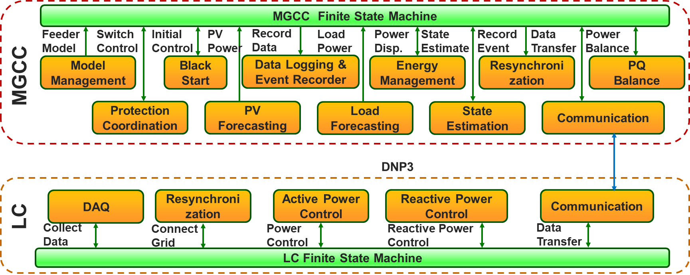

Figure 1 MGCC function block overview

## 2.2 User Access Levels

This controller is open source software for Beta version. The every detailed setting and program is available to users.

The MGCC available functions for the beta version are finite state machine, planned/unplanned islanding, topology identification, resynchronization, black start, and communication. The LC available functions are communication, active/reactive power control, resynchronization, and DAQ.

**3.0 GETTING STARTED**

# GETTING STARTED

Getting started section explain how to get the controller software and install it on device. The detailed manual and test procedure is also involved including instructions, how to use this function, how to test this function, and examples.

## 3.1 Download, Installation and Requirement

MG controller software can be downloaded from Github which has been listed in the reference part. If you have successfully join our develop team. You may pull from the master branch and get the entire package.

This MGCC is programmed utilizing LabVIEW 2016. There are several LabVIEW package required to be installed before running the MGCC. The requirements are listed as follows,

1. Labview 2016
2. Labview real-time 2016
3. Labview DNP3
4. Labview mathscript
5. Labview FTP
6. C-RIO (CompactRIO) module
7. Labview advance signal processing toolkit
8. Labview watchdog timer

At the same time, the software in the compactRIO should also be installed according to the above requirements. Note that they can be installed through NI Measurement & Automation Explorer (MAX).

1. **MICROGRID CENTRAL CONTROLLER**

# MICROGRID CENTRAL CONTROLLER

The entire project architecture can be found in the MGCC_v2 project explorer, shown in *Figure 1*. In this section, the functionality of each sub-function is descripted. The related Vis can be found in the named virtual folders. The function blocks in MG controller are listed as follows,

1. Black start
2. Communication
3. Data logging (Event recorder)
4. Energy Management
5. Finite State Machine
6. Load Forecasting
7. Model Management
8. PV Forecasting
9. State Estimation
10. Planned/Unplanned Islanding
11. Topology Identification
12. Fault and abnormal state control
13. Resynchronization

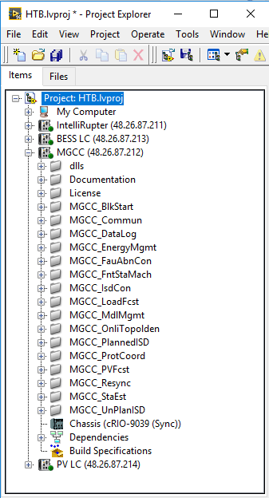

Figure 2 Example Project Explorer

## 4.1 Finite State Machine

### 4.1.1 Functionality description

FSM is the core function block for the MGCC. It classifies and describes which state the MGCC stays in and which could be the next jumping state. It also gathers the feedbacks and inputs from the LCs and other functions.

### 4.1.2 Function Block diagram

As shown in *Figure 3*, the block diagram of the finite state machine shows the jumping conditions and the possible destinations of states. The detailed description of each state is shown in *Table 1*. Basically, there are ten states MGCC FSM. Other function blocks will generate flags or events which could determine the next/destination of the current state once every control instant. Meanwhile, the destinations of states are listed in *Table 2*.



Figure 3 State machine for MGCC

Table 1 MGCC state definition

|  |  |  |  |
| --- | --- | --- | --- |
|  | State Name | Abbr. | Note |
| 1 | OFF | OFF | Power OFF |
| 2 | Standby | STD | Ready to run, update measurements |
| 3 | Grid-connected | GC | Microgrid connected to grid |
| 4 | Islanded | ISD | Microgrid Islanded |
| 5 | Grid-connected to Islanded, intentional | G2I_IN | Planned Islanding |
| 6 | Grid-connected to Islanded, unintentional | G2I_UN | Unplanned Islanding |
| 7 | Islanded to Grid-connected | I2G | Resynchronization |
| 8 | Blackstart | BKS | Start MG from Islanding |
| 9 | Abnormal | ABN | Some function blocks cannot run |
| 10 | Fault | FLT | Most of function blocks can run |

Table 2 MGCC state transition events

|  |  |  |  |
| --- | --- | --- | --- |
| Current State | Next State | Transition Event # | Transition Event Description |
| OFF | Standby | 1.1 | Power up, initialization, etc. |
| Abnormal | 1.2 | Abnormal detected |
| Fault | 1.3 | Any fault detected |
| Standby | Grid-connected | 2.1 | Grid-connected state detected |
| Islanded | 2.2 | Islanded state detected |
| Blackstart | 2.3 | Blackstart command received |
| Standby | 2.4 | No fault detected, no other state detected |
| Abnormal | 2.5 | Abnormal detected |
| Fault | 2.6 | Any fault detected |
| Grid-connected | G2I_UN | 3.1 | Unintentional Grid-connected to Islanded state detected |
| G2I_IN | 3.2 | Intentional Grid-connected to Islanded state detected |
| Grid-connected | 3.3 | Still in Grid-connected State |
| Abnormal | 3.4 | Abnormal detected |
| Fault | 3.5 | Any fault detected |
| Islanded | I2G | 4.1 | Islanded to Grid-connected state detected |
| Islanded | 4.2 | Still in Islanded State |
| Abnormal | 4.3 | Abnormal detected |
| Fault | 4.4 | Any fault detected |
| Grid-connected to Islanded, unintentional  (G2I_UN) | Islanded | 5.1 | Transition to Islanded state succeeded |
| Standby | 5.2 | Transition to Islanded state failed, microgrid outage |
| G2I_UN | 5.3 | Still in this transition state |
| Abnormal | 5.4 | Abnormal detected |
| Fault | 5.5 | Any fault detected |
| Grid-connected to Islanded, intentional  (G2I_IN) | Islanded | 6.1 | Transition to Islanded state succeeded |
| Standby | 6.2 | Transition to Islanded state failed, microgrid outage |
| G2I_IN | 6.3 | Still in this transition state |
| Abnormal | 6.4 | Abnormal detected |
| Fault | 6.5 | Any fault detected |
| Islanded to Grid-connected (I2G) | Grid-connected | 7.1 | Transition to Grid-connected state succeeded |
| Standby | 7.2 | Transition to Grid-connected state failed, microgrid outage |
| I2G | 7.3 | Still in this transition state |
| Abnormal | 7.4 | Abnormal detected |
| Fault | 7.5 | Any fault detected |
| Blackstart | Islanded | 8.1 | Black start succeeded |
| Standby | 8.2 | Black start failed |
| Blackstart | 8.3 | Still in this transition state |
| Abnormal | 8.4 | Abnormal detected |
| Fault | 8.5 | Any fault detected |
| Abnormal | Standby | 9.1 | Abnormal cleared, go back to previous state |
| Grid-connected | 9.2 | Abnormal cleared, go back to previous state |
| Islanded | 9.3 | Abnormal cleared, go back to previous state |
| G2I_UN | 9.4 | Abnormal cleared, go back to previous state |
| G2I_IN | 9.5 | Abnormal cleared, go back to previous state |
| I2G | 9.6 | Abnormal cleared, go back to previous state |
| Blackstart | 9.7 | Abnormal cleared, go back to previous state |
| Abnormal | 9.8 | Abnormal not cleared |
| Fault | 9.9 | Any fault detected |
| Fault | Fault | 10.1 | Any fault not cleared |
| Abnormal | 10.2 | Fatal fault cleared, abnormal detected |
| Standby | 10.3 | All faults cleared, no abnormal condition |
| OFF | 10.4 | Manually control |

### 4.1.3 Algorithm flow chart

The flow chart of finite state machine is shown in Figure 4. It can be observed that the jumping condition can be manually determined or determined by Flags. All these flags come from sub-functions and LC. In each state, there are different enabled functions.

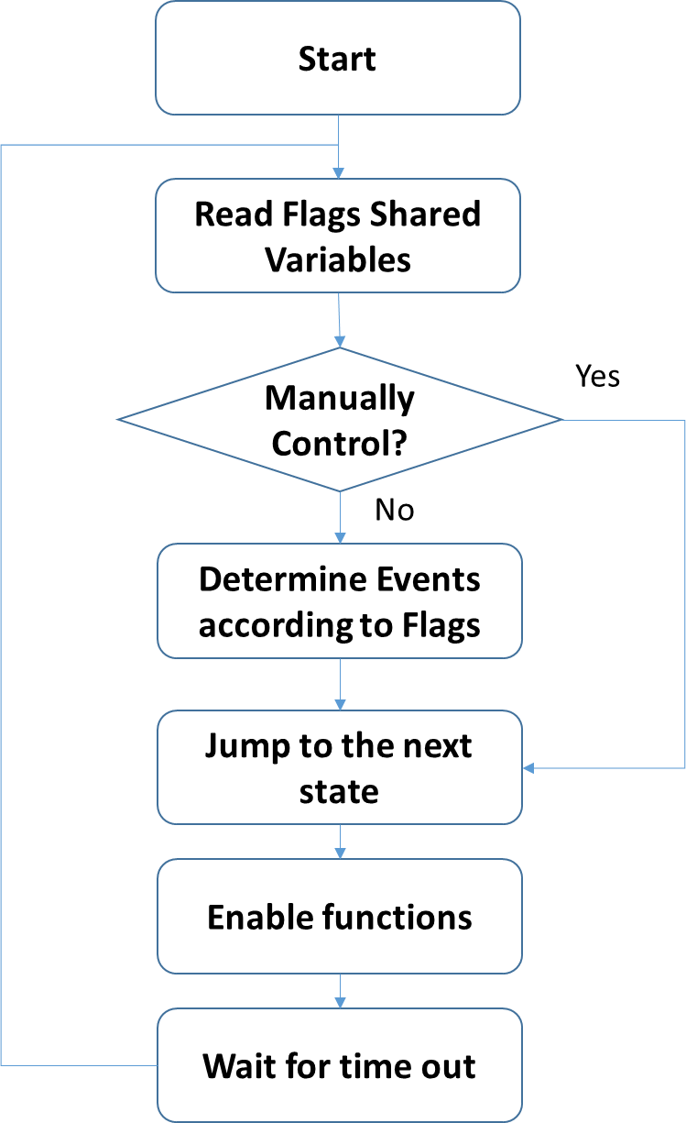

Figure The flow chart for the finite state machine

### 4.1.4 Function inputs and outputs

The finite state machine inputs and outputs are listed in *Table 3*.

Table 3 FSM inputs and outputs

|  |  |
| --- | --- |
| **Inputs** | **Outputs** |
| Flags from LC and sub-functions | Enable function signals |
| Manually control signals | Next state signals |
| Current state |  |
| Feedbacks from functions and LC |  |

## 4.2 Model Management

### 4.2.1 Functionality description

Model management is the initialization function for the MGCC. The basic function is to load the feeder information and generate the inputs for other sub-functions.

### 4.2.2 Function Block diagram

The block diagram for model management is straight forward which can be combined with flow chart together, shown in *Figure 5*. Basically, all the feeder information come from the FTP and will be converted into shared variables utilized by other sub-functions. Note that the shared variables can be replaced with global variables.

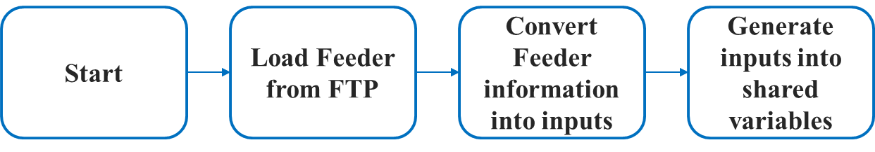

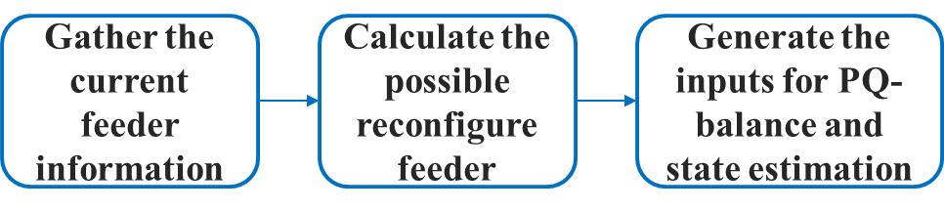

Figure 5 Model management flow chart

### 4.2.3 Function inputs and outputs

Table 4 Model management inputs and outputs

|  |  |  |
| --- | --- | --- |
|  | **Inputs** | **Outputs** |
| Static one | Initial feeder information (From CSV) | Feeder line impedance |
| Initial feeder load demand |
| Feeder connection information |
| Dynamic one | Current feeder information (From LCs) | Feeder inputs for PQ balance |
| Feeder inputs for state estimation |

## 4.3 State Estimation

### 4.3.1 Functionality description

State estimation is to estimate the current power flow with limited feeder information. Here, for a reconfigurable feeder, the state estimation function block could estimate the three phase unbalanced Feeder which can be either island or grid connected.

### 4.3.2 Function Block diagram

The block diagram for state estimation is shown in Figure 6. The state estimation function block requires feeder information from LCs and main grid. In the initialization state, it gather information from model management function and set up the basic feeder information. Then the feeder information will be renewed once the LC and main grid have any updates. The feeder information will be converted into inputs of the Matlab based state estimation functions and the results such as error rate and voltage difference will be analyzed after estimation.

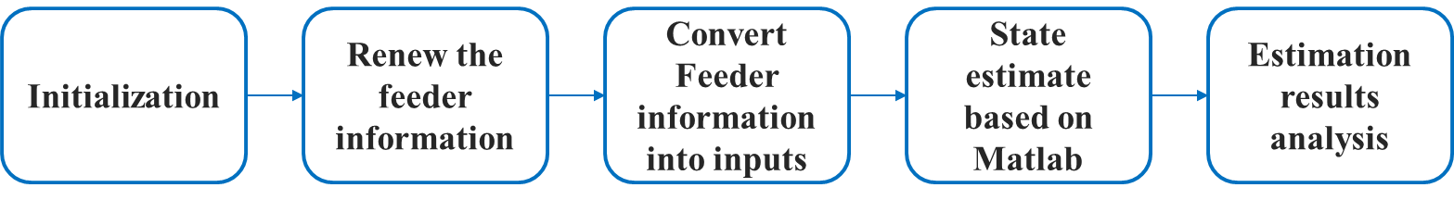

Figure 6 State estimation block diagram

### 4.3.3 Algorithm flow chart

The flow chart of the state estimation is shown in Figure 7.

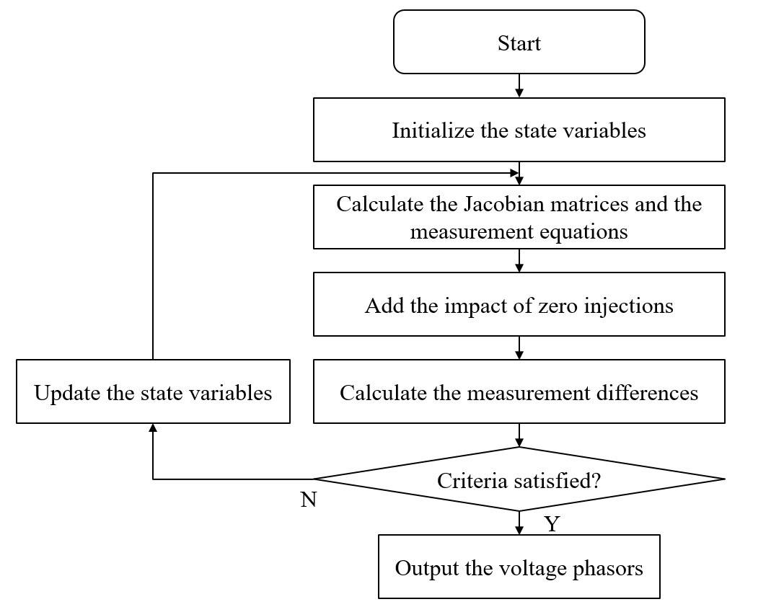

Figure 7 Flow chart of the state estimation algorithm

### 4.3.4 Function inputs and outputs

Table 5 State estimation inputs and outputs

|  |  |
| --- | --- |
| **Inputs** | **Outputs** |
| Feeder information (from model management) | Estimated node voltage |
| Renewed feeder information (from LC and main grid) | Estimated node angle |

## 4.4 Data logging and event recording

### 4.4.1 Functionality description

This function block is to record analog (e.g., frequency or voltage measurements) and binary data (e. g., command or circuit breaker position change) during MG operation. This function block is required for measuring MG system performance and for determining root cause of events. This function block can be also used for diagnosis during debugging and testing.

### 4.4.2 Function Block diagram

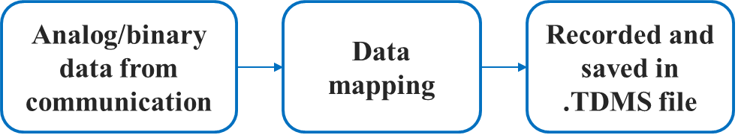

Figure 8 block diagram of data logging and event recording function block

### 4.4.3 Function inputs and outputs

Table 6 Data logging and event recording inputs and outputs

|  |  |
| --- | --- |
| **Input** | **output** |
| Analog and binary data indicating microgrid operation status, including frequency, RMS voltage, RMS current, phase angle, real (direction of power flow) and reactive power, energy, demand, PQ (voltage and current harmonic distortions, individual harmonics, voltage sags, voltage swells), reference tracking errors, power quality (distortion); losses and efficiency) | .TDMS files |

## 4.5 PV Forecast

### 4.5.1 Functionality description

This function block aims to make forecasts of the available PV generation. The forecast is based on historical PV generation data/irradiance data. The forecast is used in the Energy Management block.

### 4.5.2 Function block diagram

The block diagram of this function is shown in Figure 10. When enabled, the function reads historical data recorded by the Data Logging function block, puts them through a time series model, and output the forecast.

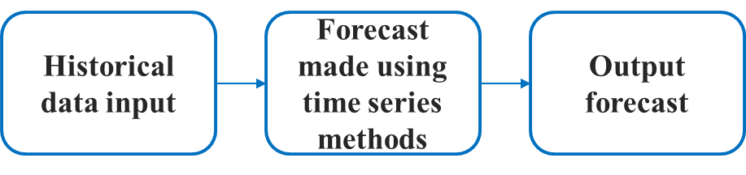

Figure 10 Block diagram of PV Forecast function block

### 4.5.3 Algorithm flow chart



Figure 11 Algorithm flow chart of PV Forecast function block

### 4.5.4 Function inputs and outputs

Table 8 PV forecast inputs and outputs

|  |  |
| --- | --- |
| **Input** | **output** |
| Historical PV generation data | Forecasted PV generation data |
| Enable signal |  |

## 4.6 Load Forecast

### 4.6.1 Functionality description

This function block aims to make forecasts of the electric demand in each load section. The forecast is based on historical load profiles. The forecast is used in the energy management block.

### 4.6.2 Function block diagram

The block diagram of this function is shown in Figure 12. When enabled, the function reads historical data recorded by the Data Logging function block, puts them through a time series model, and output the forecast.



Figure 12 Block diagram of Load Forecast function block

### 4.6.3 Algorithm flow chart



Figure 13 Algorithm flow chart of Load Forecast function block

### 4.6.4 Function inputs and outputs

Table 9 Load forecast inputs and outputs

|  |  |
| --- | --- |
| Input | output |
| Historical load data | Forecasted load data |
| Enable signal |  |

## 4.7 Energy Management

### 4.7.1 Functionality description

This function block aims to make general scheduling/dispatch strategies to reduce the electric bill in grid connected mode, and to provide energy surety to the critical load under islanded mode.

### 4.7.2 Function block diagram

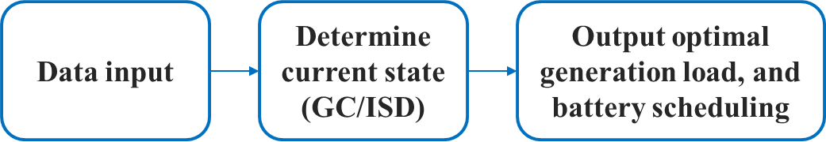

Figure 14 Block diagram of Energy Management function block

### 4.7.3 Algorithm flow chart



Figure 15 Algorithm flow chart of Energy Management function block

### 4.7.4 Function inputs and outputs

Table 10 Energy management inputs and outputs

|  |  |
| --- | --- |
| **Input** | **output** |
| Load forecast by section | PV generation schedule |
| PV forecast | Battery output schedule |
| Current battery state of charge | Backup generation schedule |
| Energy tariff and demand charge information | Switching schedule |
| Enable signal |  |

## 4.8 Communication

### 4.8.1 Functionality description

This function block(s) enables DNP3 communication from the MGCC to SCADA systems, local controllers, and other remote equipment via the DNP3 network protocol. In its current state, two separate communication function block versions are implemented in the MGCC code. One version acts as a DNP3 master station, while the other acts as a DNP3 outstation. Each communication block is independent, and can be paralleled to enable multiple communication channels, both acting as a master or outstation.

### 4.8.2 Function block diagram

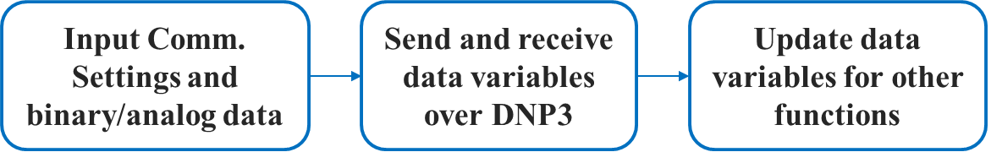

Figure 16 Block diagram of Communication function block

### 4.8.3 Algorithm flow chart

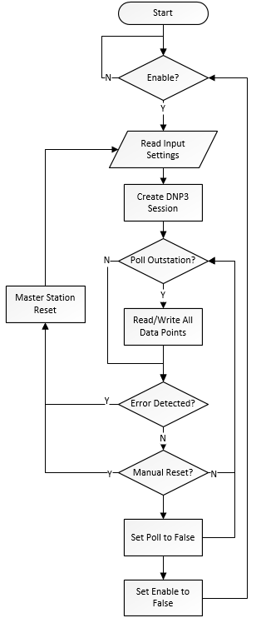

Figure 17 Algorithm flow chart for DNP3 Master Station Comm. Function

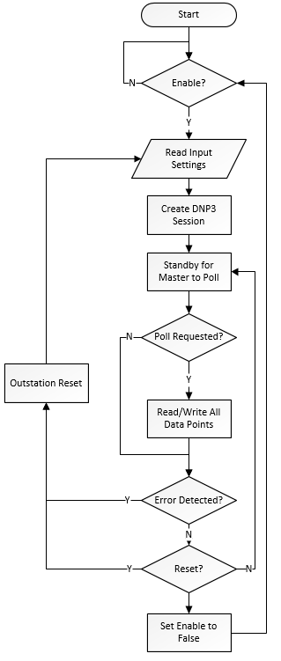

Figure 18 Algorithm flow chart for DNP3 Outstation Comm. Function

### 4.8.4 Function inputs and outputs

Table 11 Communication Master Station Function Version inputs and outputs

|  |  |
| --- | --- |
| Inputs | Outputs |
| Enable Signal | Analog Data Received |
| Poll Signal | Binary Data Received |
| Reset Signal | Error codes (if applicable) |
| Network Settings | Connection Status |
| Communication Settings |  |
| Analog Data to Send |  |
| Binary Data to Send |  |

Table 12 Communication Outstation Function Version inputs and outputs

|  |  |
| --- | --- |
| Inputs | Outputs |
| Enable Signal | Analog Data Received |
| Reset Signal | Binary Data Received |
| Network Settings | Error codes (if applicable) |
| Communication Settings |  |
| Analog Data to Send |  |
| Binary Data to Send |  |

## 4.9 Black Start

### 4.9.1 Functionality description

Black start is to restore the MG from total or partial power loss. A crucial condition for the successful restoration requires a sequence of control actions, which is built in this function block.

### 4.9.2 Function Block diagram

The block diagram for black start is shown in Figure 19. The black start function block requires information from LCs and black start command from central controller. In the initialization state, it gathers information from local controllers and central controller. Then all the load and DERs’ switches will be switched off. After all the disconnecting status information are confirmed, the black start procedure will be initialized. The battery system will be started at the first step. Then the PV will be connected after checking battery’s connecting status. The system will pick up as much load as it can after the PV connected.

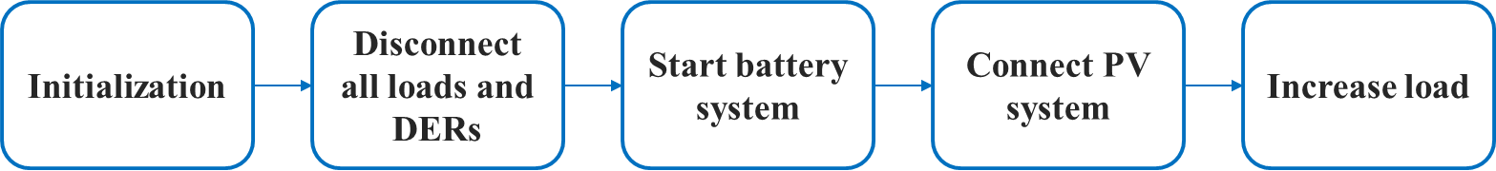

Figure Block diagram for Black Start

### 4.9.3 Algorithm flow chart

The flow chart of black start is shown in Figure 20.



Figure 20 Flow chart of the black start procedure

### 4.9.4 Function inputs and outputs

Table 13 Black Start inputs and outputs

|  |  |
| --- | --- |
| **Inputs** | **Outputs** |
| Local controller information (Switch status, Frequency and voltage) | Switch status reference |
| Central controller information (black start command) | Black start failure flag |

## 4.10 Planned/Unplanned Islanding

### 4.10.1 Functionality description

Planned islanding is designed to make the transition from grid-connected mode to islanded mode with an optimal boundary dependent on the real-time output of DERs. This allows users to intentionally disconnect the microgrid from the grid interface for routine maintenance or per request of main grid operators.

On the other hand, unplanned islanding function is a passive function. Once an unplanned islanding happens, it will identify the islanding state and report to the FSM.

### 4.10.2 Function block diagram

The block diagram of planned islanding is as shown in Figure 23. At the initialization stage, MGCC collects information and measurements from local controllers.

With all the information in place, MGCC determines the optimal boundary that best utilizes the DER output, minimizes the transient during transition to the islanded mode, and maintain stability of the microgrid. Once the optimal boundary is determined, the PCC for the islanding is determined as the point where the grid interfaces the boundary.

The next step is adjusting the DER output such that it matches the total load in the islanded microgrid to minimize the transient during the islanding process. The MGCC will issue a set of active and reactive power reference to the BESS local controller to match the generation and load.

The final step is to check if the DER generation has matched the load well. If yes, the MGCC issues commands to open the IntelliRupter on PCC. If not, the MGCC will repeat the process until the criteria are met.

Similar to the planned islanding, unplanned islanding only have the initialization and detecting state. During the detecting state, with the topology signal from the topology identification, it will identify the current MG state.

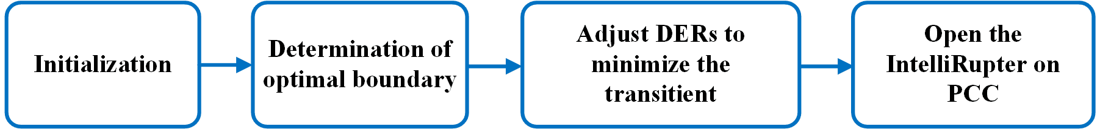

Figure 23 Block diagram of the Planned Islanding function

### 4.10.3 Algorithm flow chart

The flow chart of the planned islanding module is shown in Figure 24.

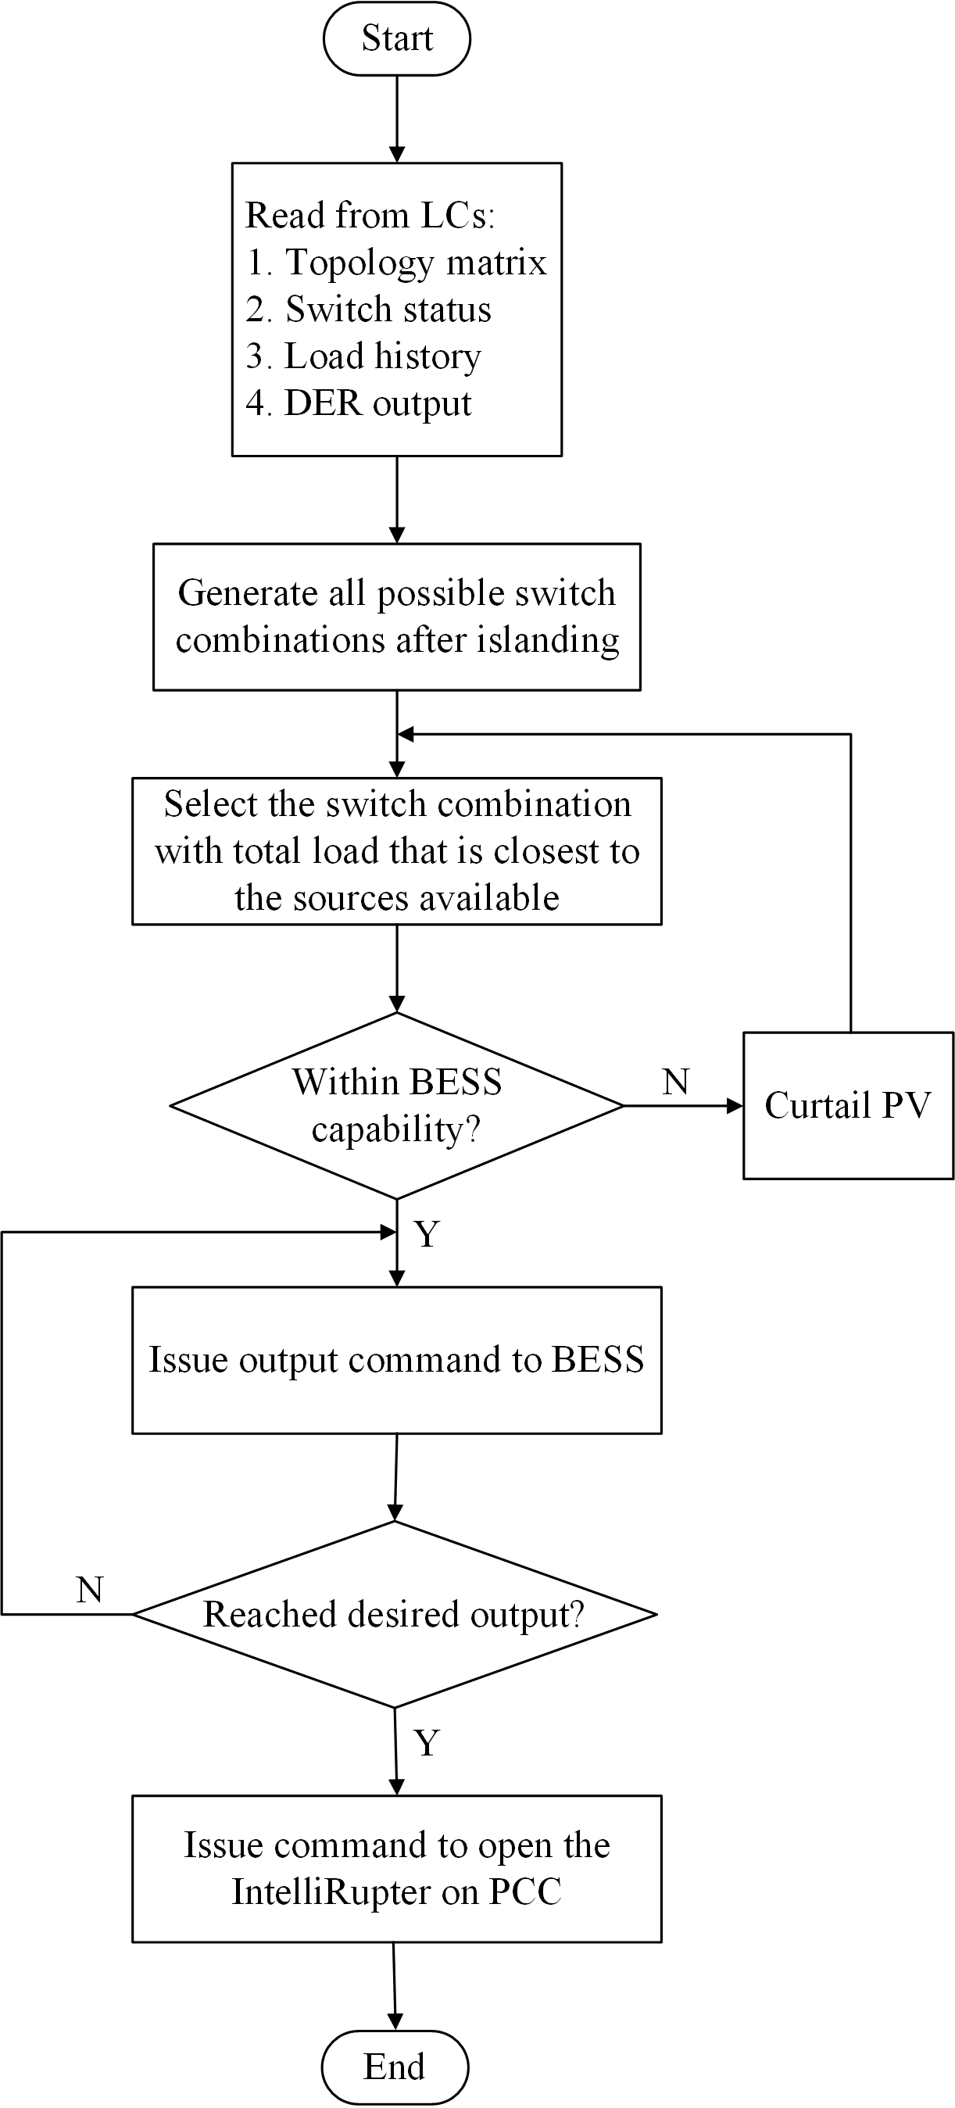

Figure 24 Flowchart of the planned islanding module

### 4.10.4 Function inputs and outputs

Table 15 Inputs and Outputs of the planned islanding function

|  |  |
| --- | --- |
| **Inputs** | **Outputs** |
| Local controller information (Switch status, active and reactive power of DERs) | Switch commands |
| Central controller information (system parameters) | Active and reactive power reference for BESS |

Table 16 Inputs and Outputs of the unplanned islanding function

|  |  |
| --- | --- |
| **Inputs** | **Outputs** |
| Current MG topology | State change signal to FSM |

## 4.11 Fault and abnormal state control

The fault and abnormal state control function is designed to deal with MGCC fault and abnormal cases including communication failure, inputs and outputs errors, and data errors. Under these abnormal cases, the FSM would move from the normal state to the abnormal state with the signal feedback from the fault and abnormal state control function.

As shown in Figure 25, with an abnormal error happens, the fault and abnormal state control function would first find out the error through the feedback from each function block and then identify the error type. If it is an abnormal error, the fault and abnormal state control function would send trigger signal to the FSM and then move into the abnormal state. In the abnormal state, the fault and abnormal state control function would keep checking the error feedback from the functions. If the error disappeared, the fault and abnormal state control function would again send trigger signal to the FSM to move back to the previous state. Otherwise, the FSM would stay in the abnormal state and wait for the further information.

As shown in Figure 26, with a fault error happens, the fault and abnormal state control function would first find out the error through the feedback from each function block and then identify the error type. If it is a fault error, the fault and abnormal state control function would send trigger signal to the FSM and then move into the fault state. In the fault state, the FSM would disable most of the existing functions and showing the fault information to the SCADA. In this case, only if the manually restart can be done on the MGCC.

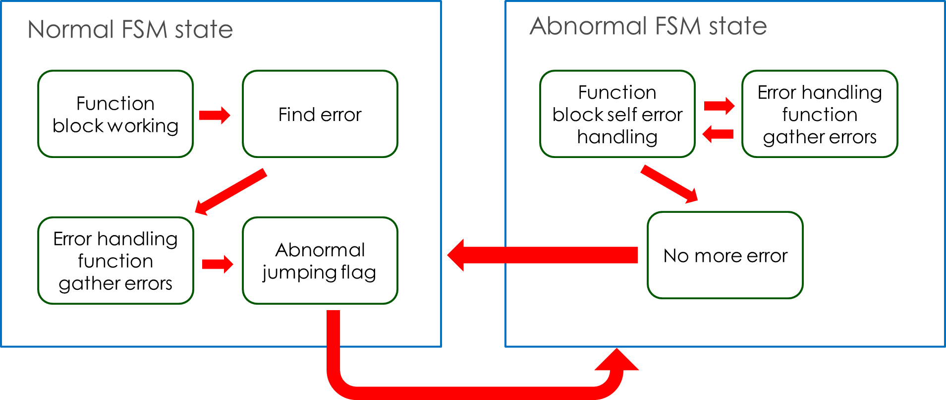

Figure 25 the block diagram of the fault and abnormal state control function with an abnormal error happens

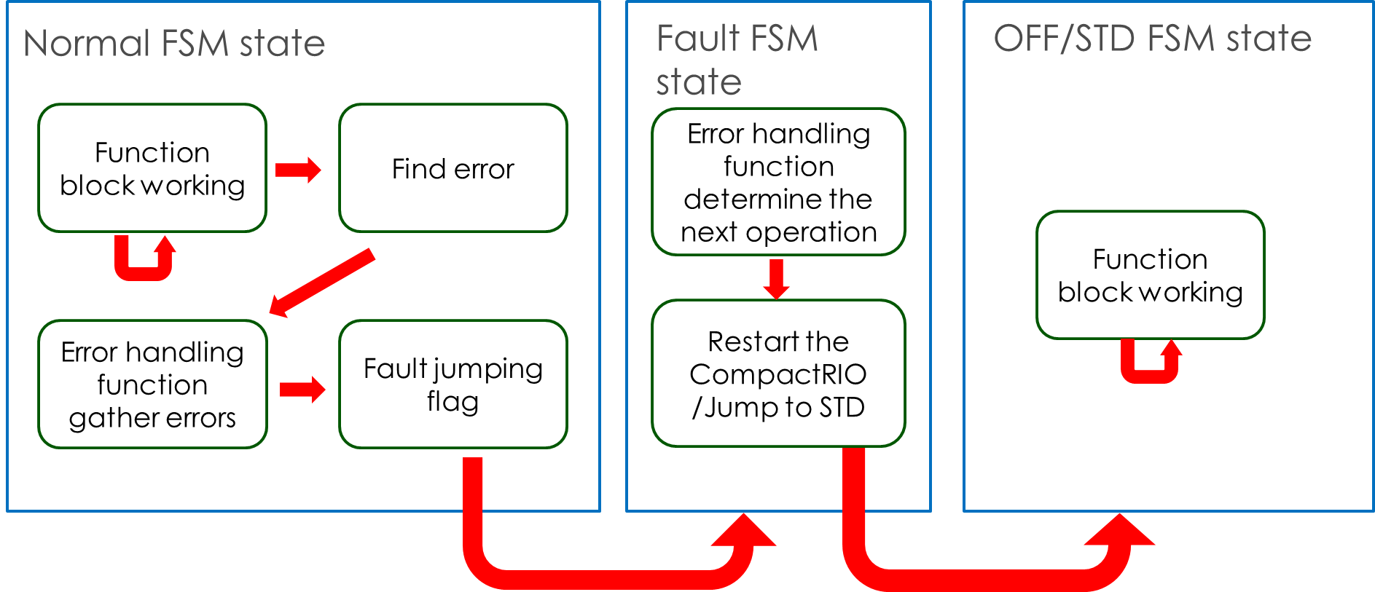

Figure 26 the block diagram of the fault and abnormal state control function with a fault error happens

## 4.12 Resynchronization

This function is described in 3.3.3

## 4.13 Topology Identification



Figure 27 the flowchart of the topology identification

Table 17 PQ balance inputs and outputs

|  |  |
| --- | --- |
| **Inputs** | **Outputs** |
| Switch status | Topology matrix for other functions to use |
| Voltage measurement and Component status to determine the active devices |  |

## 4.14 Islanded state control

The objective of this function is to open the IntelliRupters when unexpected circumstances happen, i.e., after planned islanding or temporal/permanent fault. The flow chart of the function is shown in Figure 20. The basic idea is first to get the enable signal and controllable IntelliRutper list from Finite State Machine and topology identification functions. Then Islanded State Control will determine which IntelliRupter should be opened and thus send out control commands to communication function to open these switches. Note that Islanded State Control function is designed to work with the planned islanding and protection coordination functions.

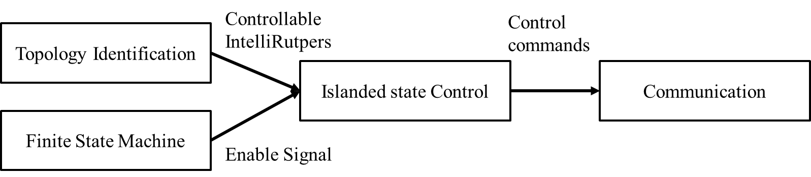

Figure 28 Block diagram of the Islanded State Control function

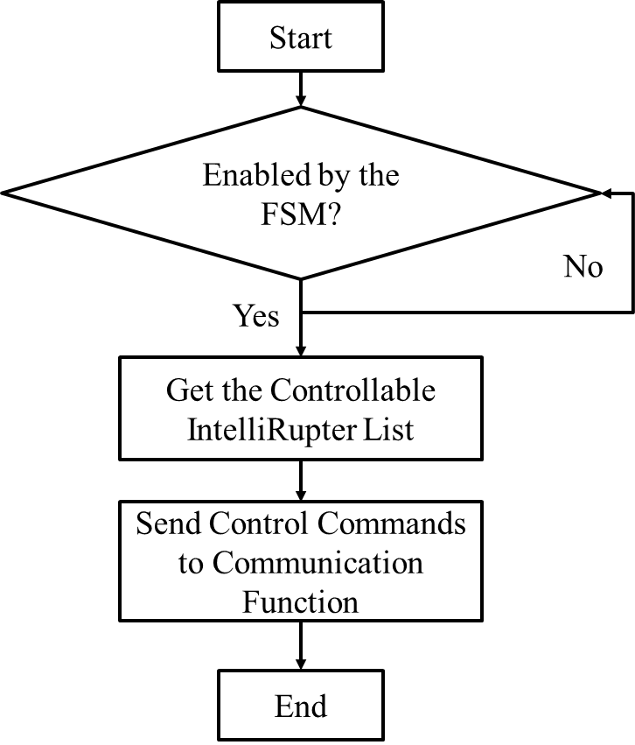

Figure 29 the flow chart of the Islanded State Control function

**5.0 MICROGRID LOCAL CONTROLLER**

# 5. MICROGRID LOCAL CONTROLLER

## 5.1 Active power control

### 5.1.1 Functionality description

This function is in the LC. It controls the output power of the DER during grid-connected operation, and output frequency of the DER during islanded condition. It includes inertia emulation function, P-f droop, secondary control, tertiary control, and curtailment for PV.

### 5.1.2 Function Block diagram

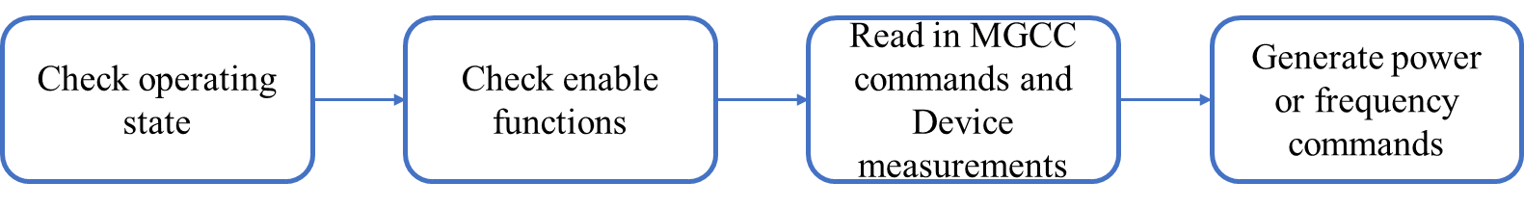

Figure 30 active power control algorithm block diagram

### 5.1.3 Algorithm flow chart



Figure 31 flow chart of the active power control algorithm

### 5.1.4 Function inputs and outputs

Table Active power control inputs and outputs.

|  |  |
| --- | --- |
| **Inputs** | **Outputs** |
| Enable signals from MGCC (inertia emulation, droop, curtailment etc) and setpoints (frequency and power, curtailment percentage, etc) | Output power reference in grid connected state. |
| Measurements from device controllers (output power, grid frequency, etc) | Output frequency reference in islanded state |

## 5.2 Reactive power control

### 5.2.1 Functionality description

This function is in the LC. It controls the output reactive power of the DER. It includes Q-v droop, voltage closed-loop regulation, and constant power factor control.

### 5.2.2 Function Block diagram

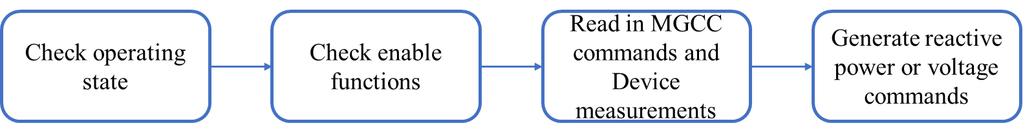

Figure reactive power control algorithm block diagram

### 5.2.3 Algorithm flow chart



Figure 33 flow chart of the reactive power control algorithm

### 5.2.4 Function inputs and outputs

Table reactive power control inputs and outputs.

|  |  |
| --- | --- |
| **Inputs** | **Outputs** |
| Enable signals from MGCC (Q-v droop, voltage regulation, etc) and setpoints (reactive power or voltage | Output reactive power power reference in grid connected state. |
| Measurements from device controllers (output power, output reactive power, grid voltage magnitude, etc) | Output voltage reference in islanded state |

## 5.3 Resynchronization

### 5.3.1 Functionality description

This function is in MGCC and LCs, and will only run in the I2G state of the FSM. The MGCC part identifies the boundary switch of the island, and send the voltage magnitude, frequency and angle difference between the two side of the boundary switch to the LC. LC part controls the DER’s output voltage to reduce the voltage differences. Once the differences are smaller than a preset threshold, the MGCC part will issue commands to close the boundary switch, and reconnect the island to the main grid.

### 5.3.2 Function Block diagram

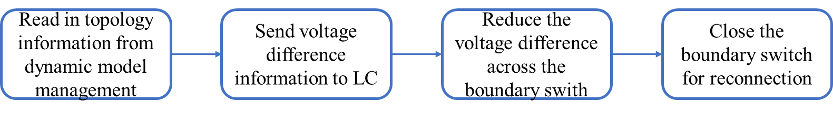

Figure resynchronization algorithm block diagram

### 5.3.3 Algorithm flow chart



Figure 35 flow chart of the resynchronization algorithm

### 5.3.4 Function inputs and outputs

Table Resynchronization MGCC part inputs and outputs.

|  |  |
| --- | --- |
| Inputs | Outputs |
| Topology information from dynamic model management | Voltage magnitude difference; Frequency difference; and angle difference to local controllers |
| Voltage magnitude difference; Frequency difference; and angle difference from SCADA |  |

Table 21 resynchronization LC part inputs and outputs.

|  |  |
| --- | --- |
| Inputs | Outputs |
| Enable signals from MGCC | Output voltage and frequency reference |
| Voltage magnitude difference; Frequency difference; and angle difference |  |
| Measurements from device controllers (output power, grid frequency, etc) |  |

**6.0 INSTRUCTION FOR UTILIZING THE MICROGRID CONTROLLER WITH A NEW FEEDER**

# INSTRUCTION FOR UTILIZING THE MICROGRID CONTROLLER WITH A NEW FEEDER

## 6.1 Microgrid topology acquiring

In order to utilize the proposed microgrid controllers with a new feeder, the first step is to acquire the microgrid topology. There are two famous softwares to set up the microgrid single line topology, i.e., CYME and SynerGEE Electric. Here, taking CYME as an example, following the steps discussed below, the inputs of the model management can be generated. One thing needs to mention is that this method requires Matlab 2016 or advanced version to support.

As shown in Figure 36, the first step is to build up a detailed microgrid model in CYME. Figure 37 gives the full model for EPB system as an example. Then, you can push the button shown in Figure 38 to get the reduced model from the full model. The next step is to generate the ASCII file from the reduced model.

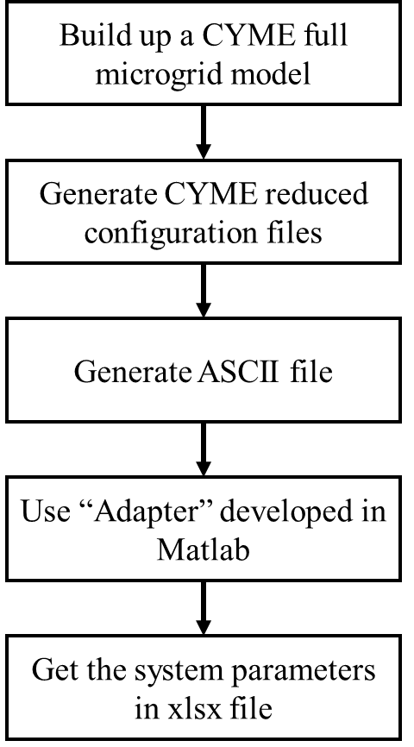

Figure the flow chart of using CYME and “Adapter” to generate the input data

The exported data from CYME contains three .txt files. The load.txt contains the load information of each node. The network.txt contains the topology information and the coordinates. The equipment.txt contains the configuration of each branch. Given the steps from Figure 39, the output ASCII file can be researched, with an example of “load.txt” shown in Figure 40. After that, you may need to use another self-defined Matlab function, “Adapter” to support. Please put the three output files of the ASCII (txt files named “load.txt”, ’ network.txt’ and “equipment.txt”) to the same folder of the “Adapter” and then run the “Adapter” in Matlab environment.

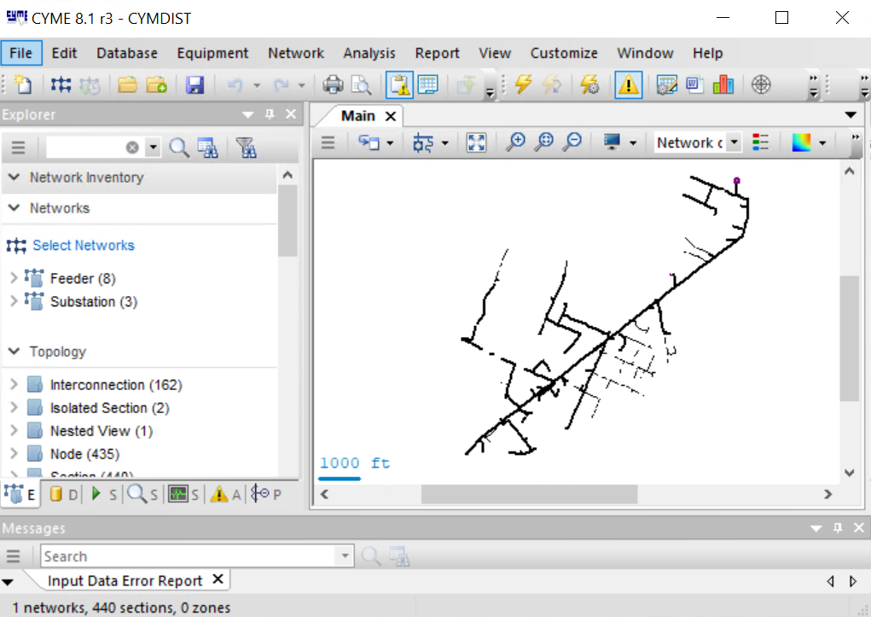

Figure the full feeder model in EPB system

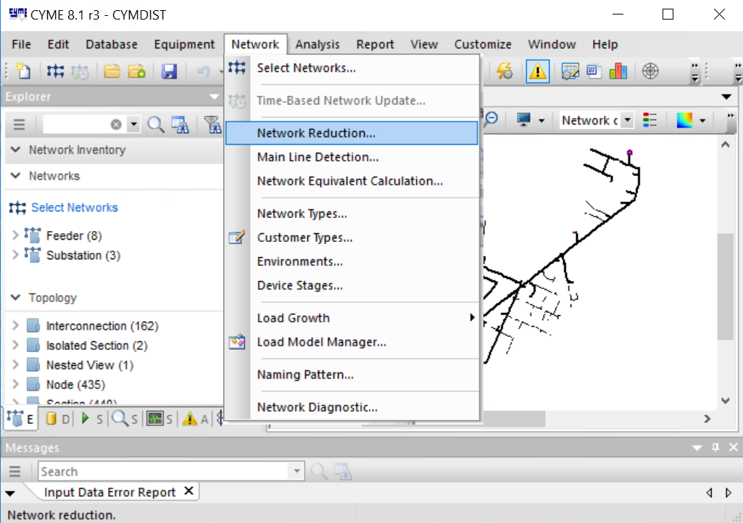

Figure Model reduction using CYME

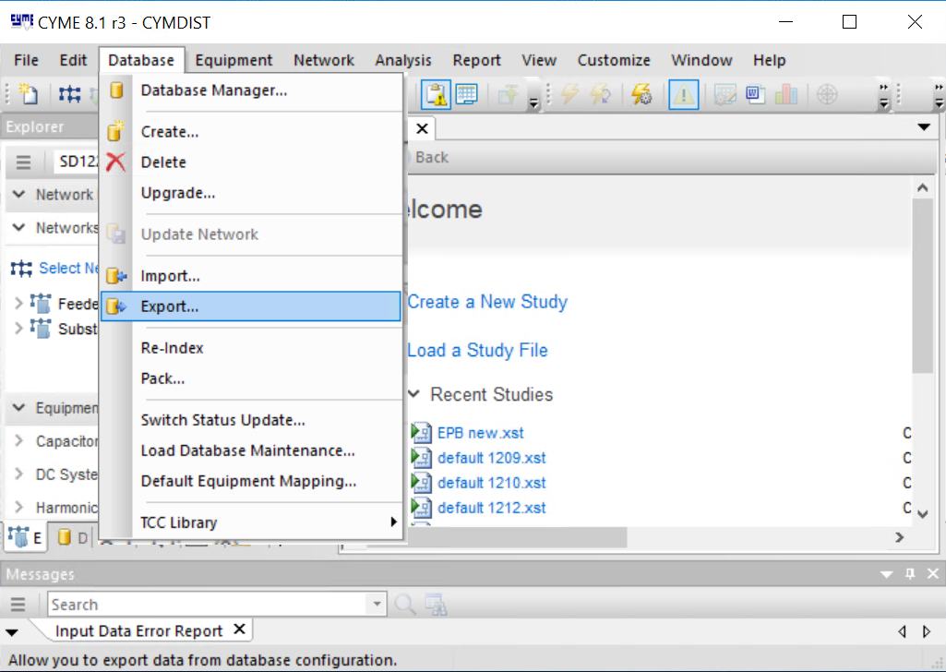

Figure 39 ASCII file Export using CYME

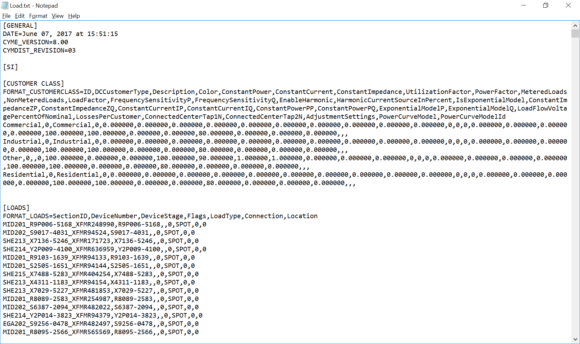

Figure 40 Example of load.txt file

Then you will get the system parameters in “User-defined name.xlsx” file under the same folder. In the “User-defined name.xlsx” file, there are eight spreadsheets. Given an example from IEEE 123-node system, as shown in Figure 41 to Figure 45, they are the general data, topology data, configuration data, load data, and the graphic data. In addition to these five spreadsheets, three feeder data named “V_node.csv”, “Y_bus.csv”, and “I_node.csv” are also generated by the “adapter”. Besides, the “Adapter” will also generate a separate csv file named “Intellirupter.csv” to indicate which line has an intellirupter installed.

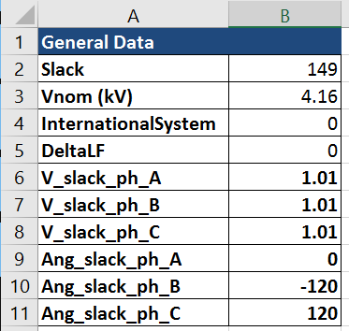

Figure 41 the spreadsheet of general data.

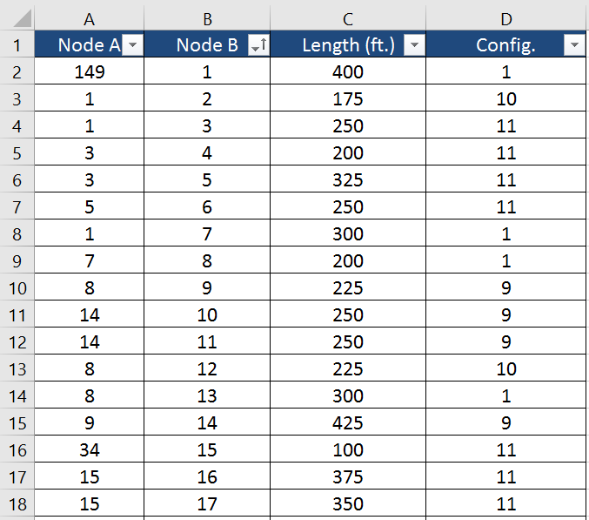

Figure 42 the spreadsheet of topology data.

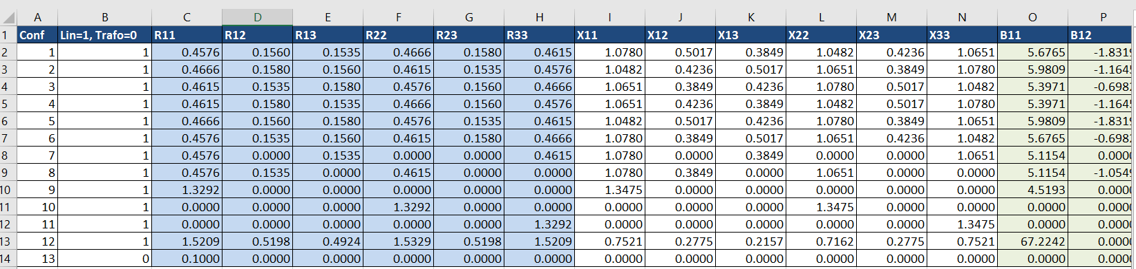

Figure 43 the configuration data spreadsheet.

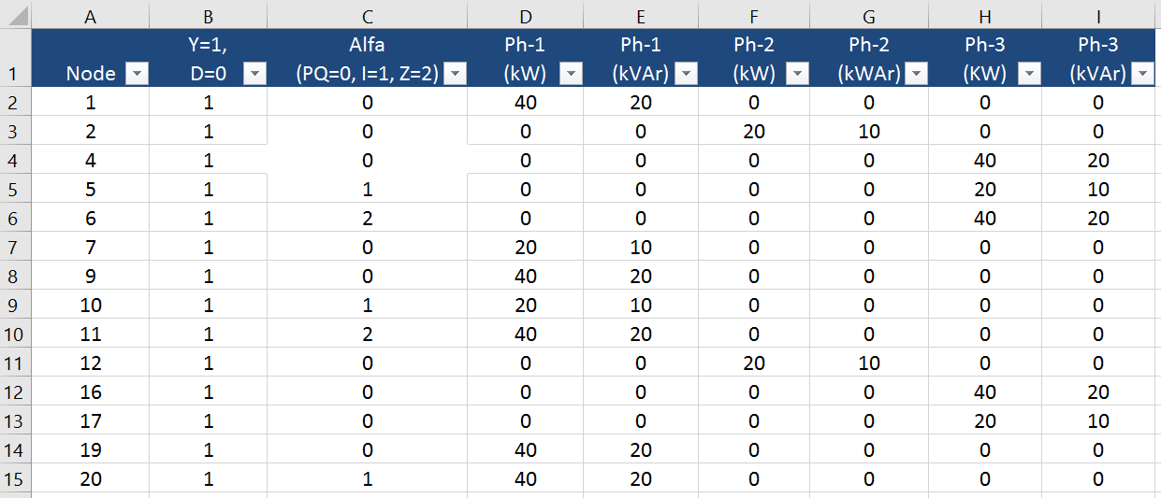

Figure 44 the load data spreadsheet.

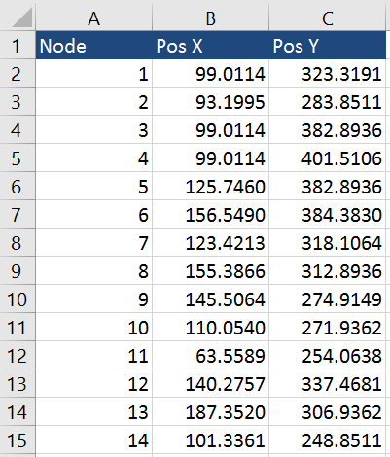

Figure 45 the graphic data spreadsheet.

In addition to the above data, the BESS and PV information should be ready before generating the input of the model management. In order to create these information with new MG feature, please open the “BESS_parameter.csv” file with excel. As shown in Figure 46, the sequence of the BESS parameters follow the following sequence: BESS location (which node is connecting with a BESS), BESS capacity, BESS power limitation, BESS SOC minimum, BESS SOC maximum, BESS voltage minimum, BESS voltage maximum, BESS frequency minimum, BESS frequency maximum, BESS number, and BESS inverter current limitation. Please **fill in the related BESS location** according to you own MG topology. Similar to the BESS, the PV parameter are listed in “PV_parameter.csv”. The PV parameters follow the sequence: PV location (which node is connecting with a PV), PV number and PV inverter current limitation. Please **fill in the related PV location** according to you own MG topology.

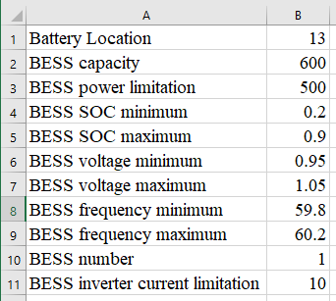

Figure the BESS parameter CSV file

In addition, the “Adapter” will provide an individual table for the locations of the intellirupters. For example, the location of the intellirupters in Opal-RT model is listed in Table 22. Note that, here “Y” for an intellirupter, “G” for a grid interface; “N” for a normal line. If the microgrid is designed without intellirupters, please still let us know the location of the grid interfaces. This table is stored in the “IntelliRutper.csv”.

Table 22 The location for the Intellirupters

|  |  |  |
| --- | --- | --- |
| Start Node | End Node | Line Type |
| 1 | 2 | G |
| 2 | 3 | N |
| 3 | 4 | Y |
| 4 | 5 | N |
| 5 | 6 | Y |
| 6 | 7 | N |
| 7 | 8 | Y |
| 7 | 9 | N |
| 9 | 10 | G |
| 4 | 11 | N |
| 11 | 12 | Y |
| 12 | 13 | N |
| 13 | 14 | Y |
| 14 | 15 | N |
| 15 | 16 | Y |
| 16 | 17 | N |
| 17 | 18 | Y |
| 18 | 19 | N |
| 19 | 20 | G |
| 16 | 21 | N |
| 12 | 22 | Y |

Besides, the PQ balance function may need some initial settings such as the PQ balance working cycle, PQ recharge min SOC, and PQ discharge max SOC. If the user do not want to change any default setting, please leave it there. These parameters are listed in the file named “PQ.csv”.

## 6.2 Create the inputs for the model management

The next step is to create the inputs for the model management function. Please open the NI-MAX and select the compact of your MGCC, shown in Figure 47.

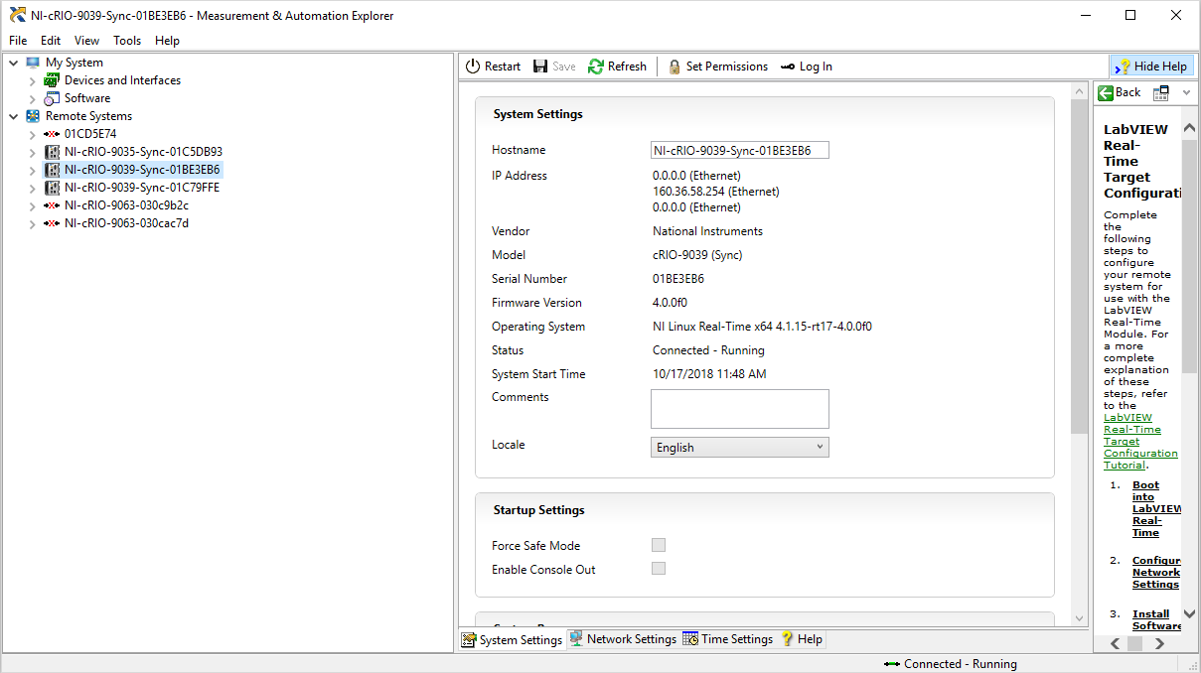

Figure the interface of the NI MAX

Then, please right click the NI-CRIO and choose “file transfer”. If it jump to ei explorer, please retry the previous step again and check whether you have successfully installed the NI-LabVIEW FTP module. If it jumps to the FTP of the compactRIO, then please find the “c” folder and go to “model management” inside of it. The next step to move the csv files listed in Table 23 to that folder. If everything succeed, please close the folder and it is done with this phase.

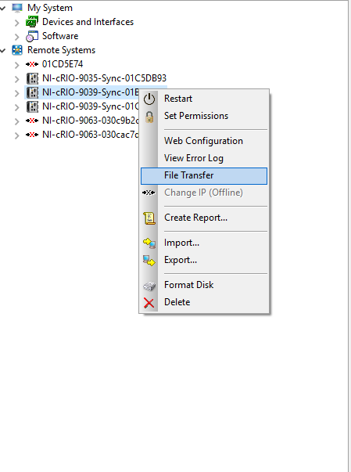

Figure file transfer selection

Table 23 conclusion of a model management file package for transferring to a new MG

|  |  |
| --- | --- |
| File name | File come from |
| BESS_parameter.csv | Model management package |
| PV_parameter.csv | Model management package |
| I_node.csv | “Adapter” |
| V_node.csv | “Adapter” |
| Y_bus.csv | “Adapter” |
| Topology.csv | “Adapter” |
| IntelliRupter.csv | “Adapter” |

## 6.3 Create the communication channels

Beside of the model management, communication channels are required to be initialized. Since the communication channels are based on the number of the IntelliRupters, BESSs, and PVs, you may need some data from the “BESS_parameter.csv”, “PV_parameter.csv”, and “IntelliRupter.csv”.

First, for the “IntelliRupter.csv” it mentions all the IntelliRupter locations. The communication data comes from these smart switches. For each IntelliRupter, we have defined 15 variables, listed in Table 24. Here, taking S0102 as an example IntelliRupter, all the description of the communication data point is given. The sequence of the IntelliRutpers communication channels follows the same one listed in the “IntelliRupter.csv”.

Table 24 The communication specification of S0102 intellirutper

|  |  |
| --- | --- |
| Variable Name | Variable meaning |
| S0102-status | On/Off status |
| S0102-MAG-A-L | Phase A Voltage magnitude on left side of the S0102 |
| S0102-MAG-B-L | Phase B Voltage magnitude on left side of the S0102 |
| S0102-MAG-C-L | Phase C Voltage magnitude on left side of the S0102 |
| S0102-MAG-A-R | Phase A Voltage magnitude on right side of the S0102 |
| S0102-MAG-B-R | Phase B Voltage magnitude on right side of the S0102 |
| S0102-MAG-C-R | Phase C Voltage magnitude on right side of the S0102 |
| S0102-FREQ-L | Frequency on left side of the S0102 |
| S0102-FREQ-R | Frequency on right side of the S0102 |
| S0102-ANG-DIFF | Angle difference between two sides of the S0102 |
| S0102-APF | Active power flow through the S0102 |
| S0102-RPF | Reactive power flow through the S0102 |
| S0102-Reserved13 | Reserved data location 1 |
| S0102-Reserved14 | Reserved data location 2 |
| S0102-Reserved15 | Reserved data location 3 |

In order to establish the communication channels between the SCADA and the MGCC, the LCs and MGCC, the BESS/PV and LCs. It is necessary to setup the DNP3 communication channels with predefined input ip address and ports. In order to setup stable communication channels, please fill in the related communication chanel tables. For example, in the “Communication_BESS_LC.csv” the first column means the parameters required for the outstation communication between LC and MGCC while the second column means the master communication between LC and BESS. The “Communication_PV_LC.csv”, “Communication_BESS_BESS.csv”, “Communication_PV_PV.csv” are almost the same with different meanings. The explanations of these inputs are listed in Table X. One thing need to mention is that for the “Communication_intellirupters_MGCC.csv”, there are four columns for BESS master, PV master, SCADA master, and SCADA outstation, respectively. Considering the real-time data requirement, for the SCADA, it is designed as bidirectional master and outstation ones.

The next step is to generate correct communication channels. For the SCADA, it has been discussed in Table 24 and related paragraphs. For BESS and PV, please refer to Table 25 for detailed information.

Table the communication specification of BESS

|  |  |  |  |
| --- | --- | --- | --- |
| BESS status name | Meaning | BESS control name | Meaning |
| BESS-STATUS | BESS on/off status | BESS-STATUS-CTRL | BESS on/off control |
| BESS-MAG | BESS voltage magnitude | BESS-APC | BESS active power control |
| BESS-FREQ | BESS frequency | BESS-RPC | BESS reactive power control |
| BESS-APO | BESS active power output | BESS-FREQ-CMD | BESS frequency command |
| BESS-RPO | BESS reactive power output | BESS-VOLT-CMD | BESS voltage command |
| BESS-SOC | BESS SOC |  |  |
| BESS-Reserved7 | Reserved |  |  |
| BESS-Reserved8 | Reserved |  |  |
| BESS-Reserved9 | Reserved |  |  |
| BESS-Reserved10 | Reserved |  |  |
| BESS-Reserved11 | Reserved |  |  |
| BESS-Reserved12 | Reserved |  |  |
| BESS-Reserved13 | Reserved |  |  |
| BESS-Reserved14 | Reserved |  |  |
| BESS-Reserved15 | Reserved |  |  |

|  |  |  |  |
| --- | --- | --- | --- |
| PV status name | Meaning | PV control name | Meaning |
| PV-STATUS | PV on/off status | PV-STATUS-CTRL | PV on/off control |
| PV-MAG | BE PV SS voltage magnitude | PV-APC | PV active power control |
| PV-FREQ | PV frequency | PV-RPC | PV reactive power control |
| PV-APO | PV active power output | PV-RESERVED4 | Reserved |
| PV-RPO | PV reactive power output | PV-RESERVED5 | Reserved |
| PV-AAP | PV Irradiance | PV-RESERVED6 | Reserved |
| PV-RESERVED7 | Reserved | PV-RESERVED7 | Reserved |
| PV-RESERVED8 | Reserved | PV-RESERVED8 | Reserved |
| PV-RESERVED9 | Reserved | PV-RESERVED9 | Reserved |
| PV-RESERVED10 | Reserved |  |  |
| PV-RESERVED11 | Reserved |  |  |
| PV-RESERVED12 | Reserved |  |  |
| PV-RESERVED13 | Reserved |  |  |
| PV-RESERVED14 | Reserved |  |  |
| PV-RESERVED15 | Reserved |  |  |

After filling in these CSV files, please make sure put these files into correct locations. For PV LCs, please put it into the model management folder in the PV FTP while please do the same thing to MGCC and BESS LC. For the BESS, PV, and SCADA, please set up related DNP3 setting in your system.

Table the example communication configuration input table

|  |  |  |
| --- | --- | --- |
|  | outstation settings | Master settings |
| IP1 |  | 160 |
| IP2 |  | 36 |
| IP3 |  | 56 |
| IP4 |  | 202 |
| DNP3 port |  | 18000 |
| DNP3 Master Address |  | 7 |
| DNP3 outstation Address |  | 8 |
| Analogue statues channel number |  |  |
| Analogue control channel number |  |  |
| Digital status channel number |  |  |
| Digital control channel number |  |  |

Table 27 all input csv files for the communication configuration

|  |  |
| --- | --- |
| Configuration file name | Configuration file meaning |
| Communication_BESS_LC.csv | The communication input for BESS local controller |
| Communication_PV_LC.csv | The communication input for PV local controller |
| Communication_BESS_BESS.csv | The communication input for BESS |
| Communication_PV_PV.csv | The communication input for PV |
| Communication_intellirupters_MGCC.csv | The communication input for MGCC |
| Communication_intellirupters_SCADA.csv | The communication input for SCADA |

## 6.4 Initialize the microgrid controllers

In this section, the initialization procedure is given for the microgrid controllers. Since all the controllers are programmed with start up setting, the model management and the communication settings will be read once they are powered on. So that when the first time controllers are powered on, please use the NI MAX to upload the related csv files and then restart the controllers to renew the settings. After this step, the controllers are all under off state and waiting for further commands from SCADA.

### 6.5 Microgrid controller operations

This section will be updated in the later versions.

1. **REPORT AND FEEDBACK**

# Report and feedback

This section provides a detailed reporting and feedback way to further improve the software of the controller.

## 7.1 Report an error

Currently, the only way to report an error could be utilizing e-mail:

[hyin8@utk.edu](mailto:hyin8@utk.edu)

[yma13@vols.utk.edu](mailto:yma13@vols.utk.edu)

[lzhu12@utk.edu](mailto:lzhu12@utk.edu)

## 7.2 Feedback

We are looking forward to any feedback from users and scholars. Please contact us in the forum or with the following e-mail address:

[hyin8@utk.edu](mailto:hyin8@utk.edu)

[yma13@vols.utk.edu](mailto:yma13@vols.utk.edu)

[lzhu12@utk.edu](mailto:lzhu12@utk.edu)